Supplementary Material

Supplementary Data and Tables
Supplementary calculation regarding CO2 removal analysis for phenolic oil (or bioasphalt) and biochar emissions for life cycle analysis:

Phenolic Oil (or Bioasphalt) CO₂ removal analysis
The phenolic oil emission factor (EF) is equal to the greenhouse gas (GHG) emissions incurred in converting phenolic oil to bioasphalt minus the equivalent CO₂ captured in the solid bioasphalt carbon after a 100-year period.
$$EF_{phenolic oil}=EF_{bioasphalt}*\frac{Y_{bioasphalt}}{Y_{phenolic oil}}-C_{phenolic oil}*CR_{bioasphalt}*CF$$
Where CF = 44 kg CO_{2e}/12 kg C
Supplementary Table 1. Values and references of the parameters for CO₂ removal analysis of phenolic oil (or bioasphalt)
Parameters | Value | Units | Notes | Reference
C_{(phenolic oil)} | 0.744 | kg C/kg phenolic oil | Phenolic oil carbon content. | (Elliott et al. 2015)
EF_{bioasphalt} | 0.16 | kg CO_{2e}/kg bioasphalt | Bioasphalt emission factor | (Zhou et al. 2020)
Y_{bioasphalt} | 0.23 | kg bioasphalt/kg biomass | Bioasphalt yield from biomass | (Zhou et al. 2020)
Y_{(phenolic oil)} | 0.525 | kg phenolic oil/kg biomass | Phenolic oil yield from biomass | (Zhou et al. 2020)
CR_{bioasphalt} | 1 | kg C/kg C | carbon sequestration rate after 100 years | (Zhou et al. 2020)
EF_{(phenolic oil)} | -2.66 | kg CO_{2e}/kg phenolic oil | Phenolic oil emission factor | This study

Biochar CO₂ removal analysis
The biochar emission factor is equal to the equivalent CO_{2e} captured in solid biochar carbon after a 100-year period. Emissions from biochar transportation and application are assumed to be negligible relative to carbon sequestered.
$$EF_{biochar}=-C_{biochar}*CR_{biochar}*CF$$
$$C_{biochar}=CY_{biochar}*\frac{C_{biomass}}{Y_{biochar}}$$
Supplementary Table 2. Values and references of the parameters for CO₂ removal analysis of biochar
Parameters | Value | Units | Notes | Reference
CY_{biochar} | 0.267 | kg C in biochar/kg C in biomass | Biochar carbon yield from biomass | (Polin et al. 2019)
C_{biomass} | 0.47 | kg C/kg biomass | Carbon content in biomass | (Polin et al. 2019)
Y_{biochar} | 0.197 | kg biochar/kg biomass | Biochar yield from biomass | (Polin et al. 2019)
C_{biochar} | 0.637 | kg C/kg | Biochar carbon content | (Polin et al. 2019)
CR_{biochar} | 0.7 | kg C/kg C | Biochar carbon sequestration rate after 100 years | (Söderqvist 2019)
EF_{biochar} | -1.63 | kg CO_{2e}/kg biochar | Biochar emission factor | This study

Supplementary Figures
The following graphs are all mostly Kernel Density Estimation (KDE) generated sample graphs.

Supplementary figures for GAN and KDE comparison with real sample data
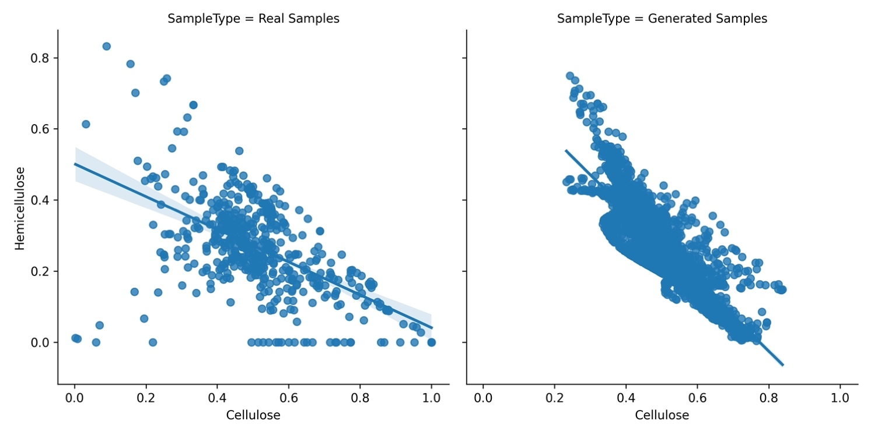
Supplementary Figure 1. Phyllis2 and INL (Left) sample data vs. Generative Adversarial Network (GAN) (Right) sample data
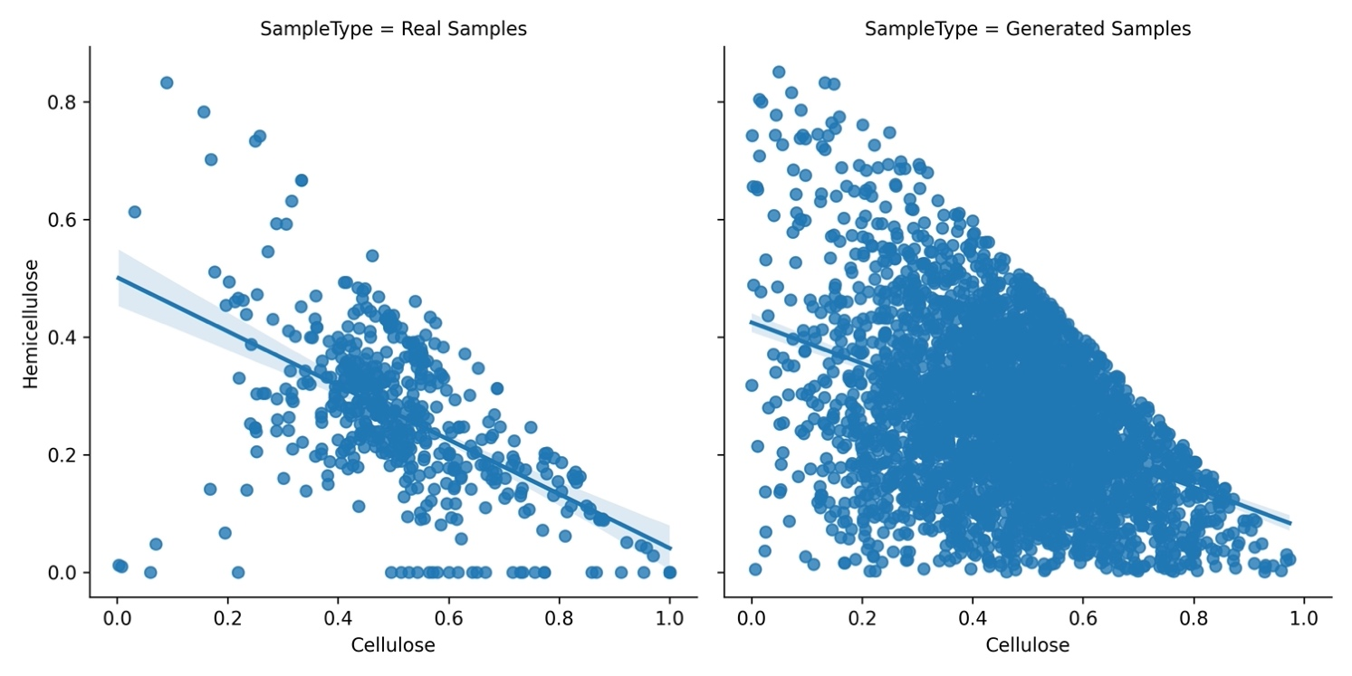
Supplementary Figure 2. Phyllis2 and INL (Left) sample data vs. the Kernel Density Estimation (KDE) (Right) sample data

Supplementary figures obtained from 3000 plus data generated through KDE
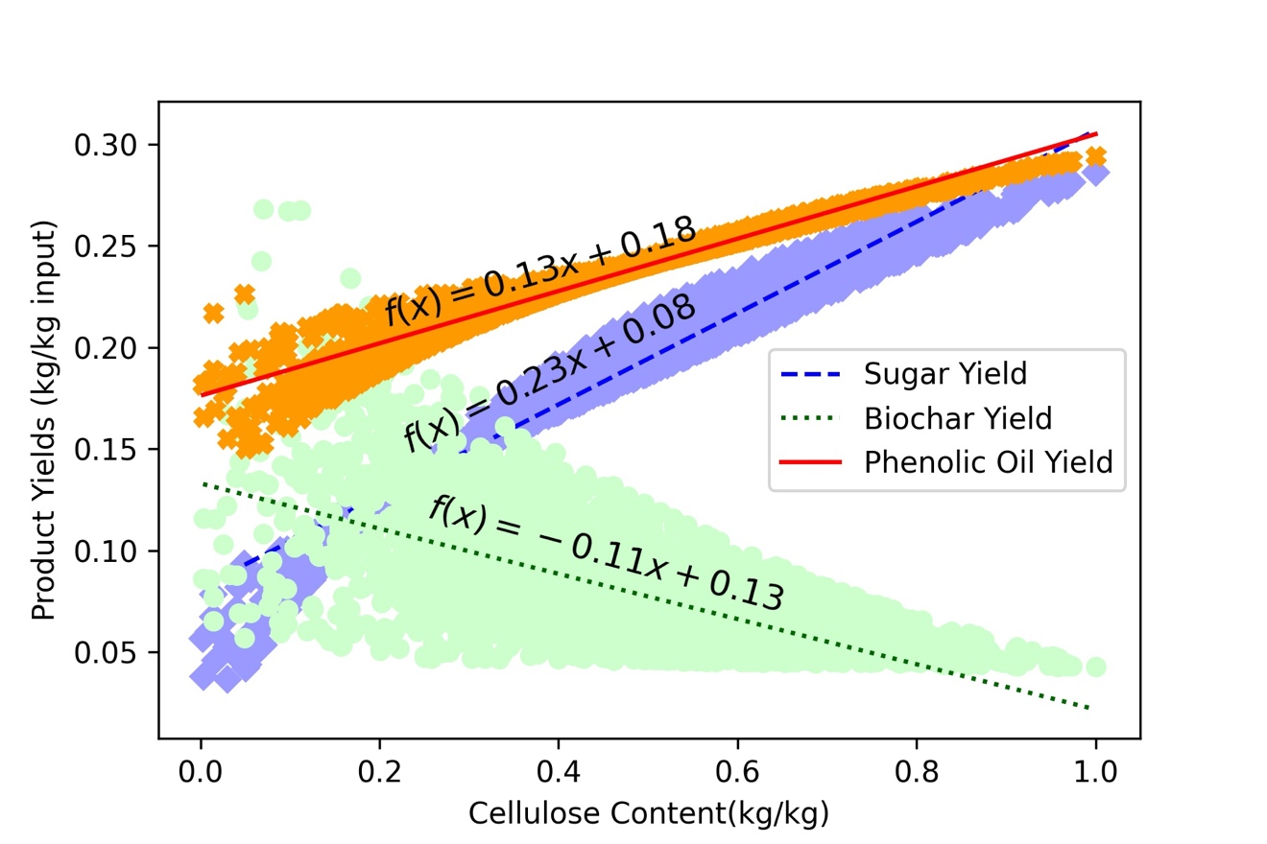
Supplementary Figure 3. Sugar, phenolic oil, and biochar autothermal pyrolysis yield vs. cellulose content
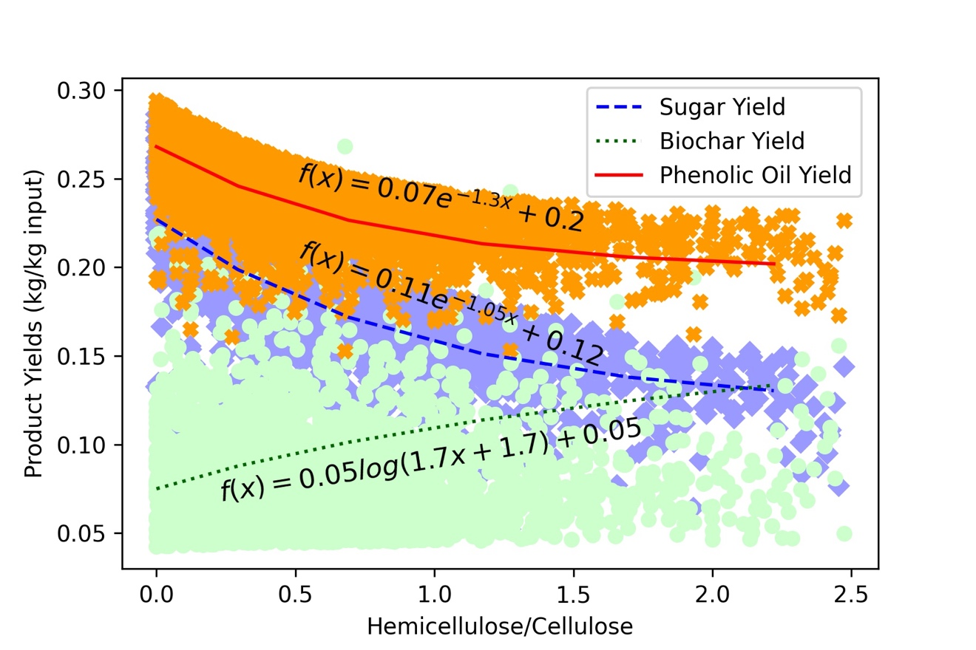
Supplementary Figure 4. Product yield relationships to hemicellulose/cellulose ratios
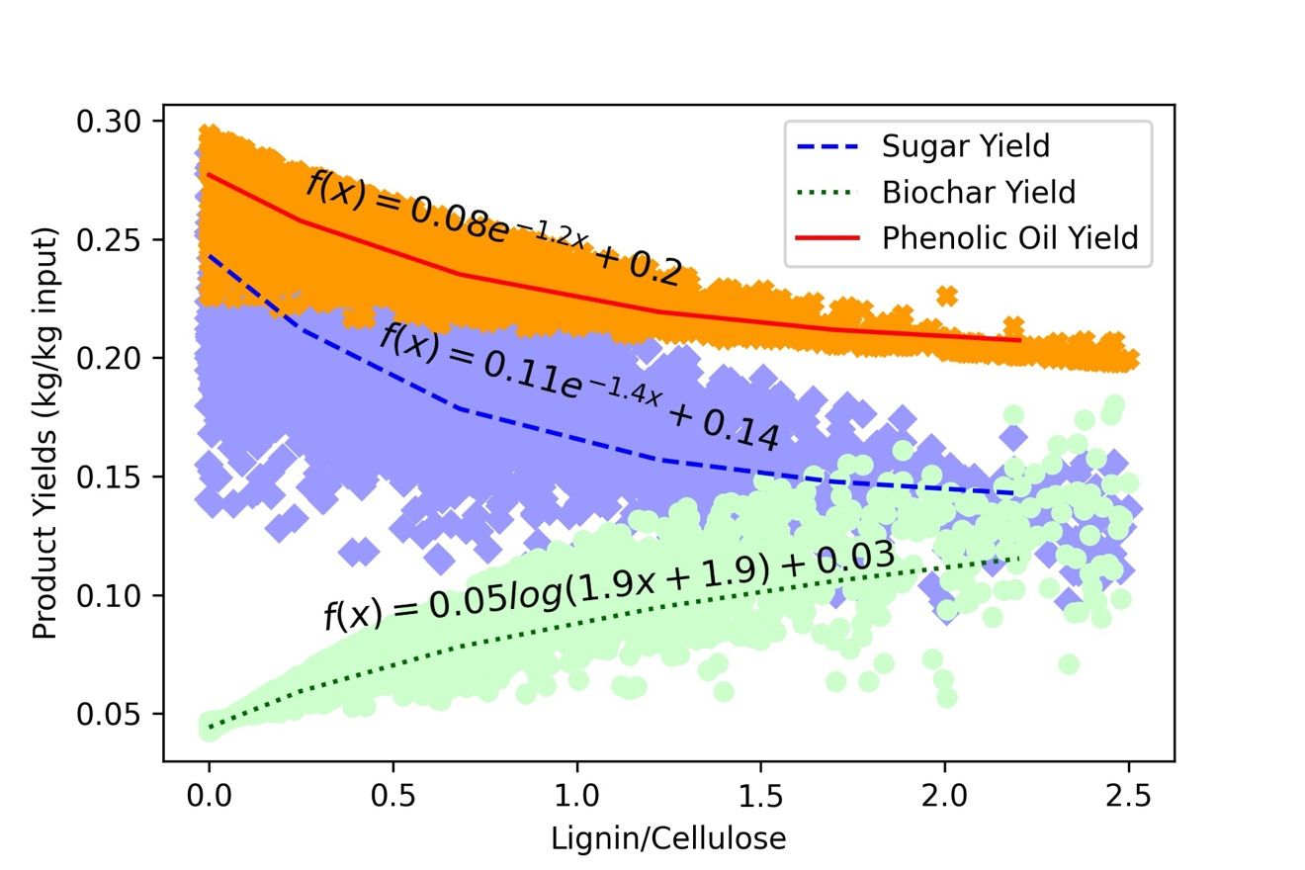
Supplementary Figure 5. Product yield relationships to lignin/cellulose ratios
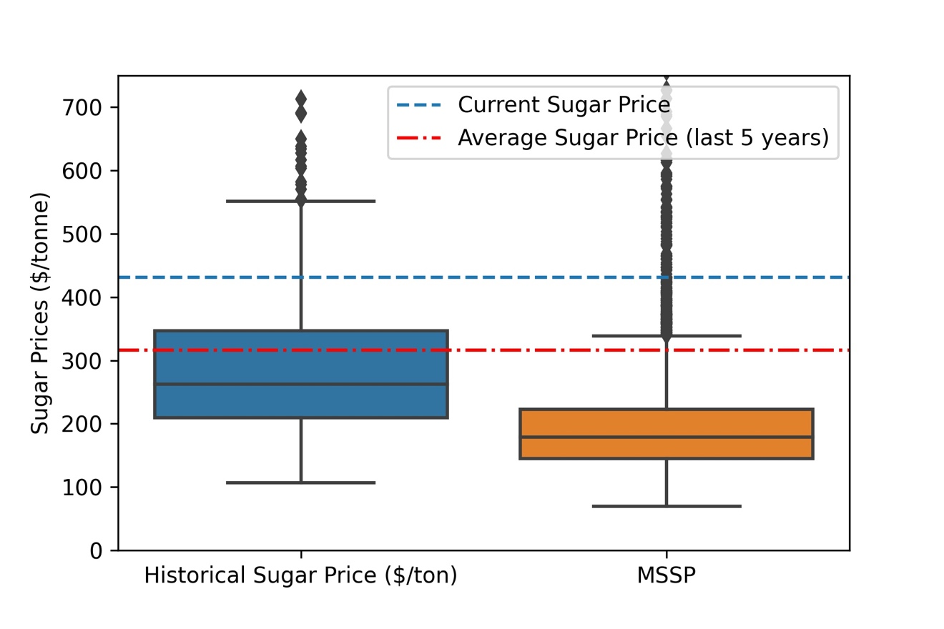
Supplementary Figure 6. Boxplot comparison of the historical sugar price (Left) and KDE minimum sugar selling price (MSSP)
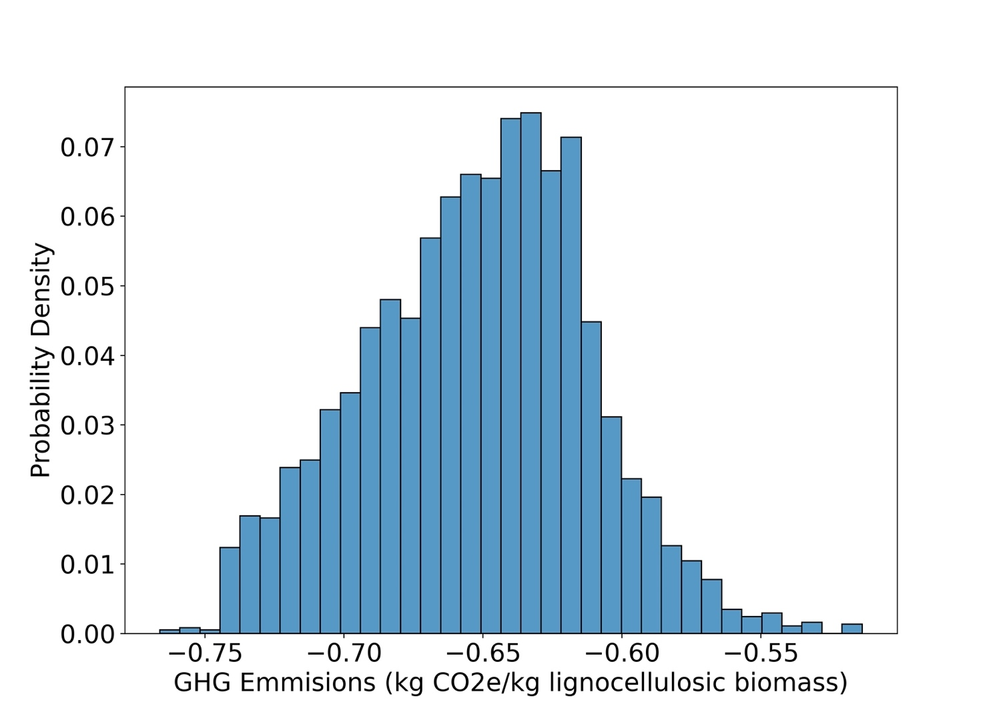
Supplementary Figure 7. Probability density vs. GHG emission of the ATP system producing sugar, phenolic oil, and biochar

Supplementary References
Elliott, Douglas C., Huamin Wang, Marjorie Rover, Lysle Whitmer, Ryan Smith, and Robert Brown. 2015. “Hydrocarbon Liquid Production via Catalytic Hydroprocessing of Phenolic Oils Fractionated from Fast Pyrolysis of Red Oak and Corn Stover.” ACS Sustainable Chemistry and Engineering 3 (5): 892–902. https://doi.org/10.1021/acssuschemeng.5b00015.
Polin, Joseph P., Howard D. Carr, Lysle E. Whitmer, Ryan G. Smith, and Robert C. Brown. 2019. “Conventional and Autothermal Pyrolysis of Corn Stover: Overcoming the Processing Challenges of High-Ash Agricultural Residues.” Journal of Analytical and Applied Pyrolysis 143 (August): 104679. https://doi.org/10.1016/j.jaap.2019.104679.
Söderqvist, Helena. 2019. “Carbon Stability of Biochar Methods for Assessment and Indication,” 41. http://kth.diva-portal.org/smash/get/diva2:1334635/FULLTEXT01.pdf.
Zhou, Xinxing, Taher Baghaee Moghaddam, Meizhu Chen, Shaopeng Wu, Sanjeev Adhikari, Song Xu, and Chao Yang. 2020. “Life Cycle Assessment of Biochar Modified Bioasphalt Derived from Biomass.” ACS Sustainable Chemistry and Engineering 8 (38): 14568–75. https://doi.org/10.1021/acssuschemeng.0c05355.

